Using the Delta Zeta App and Chapter Voting Tool to conduct a virtual vote
Step One – Upload the budget.
- Log in to Delta Zeta’s member page/app – www.deltazeta.org/sign-in.
- Upload the budget document for all members to view.
- In the Chapter Life section, select documents, and you can add any type of file for all members to view. Once an officer adds a file, only an offer can remove. However, all members and advisors can view.
- Email or message all members letting them know the budget is available for their review.
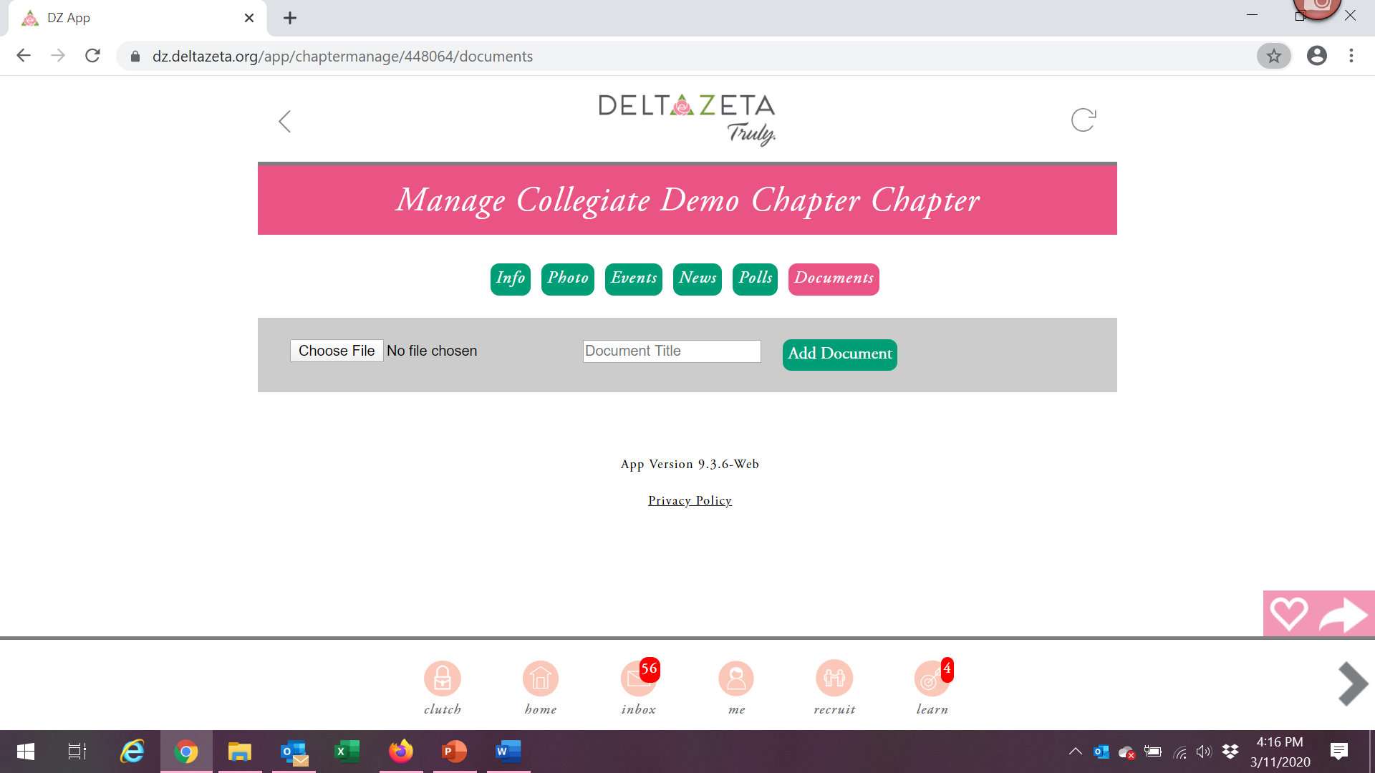
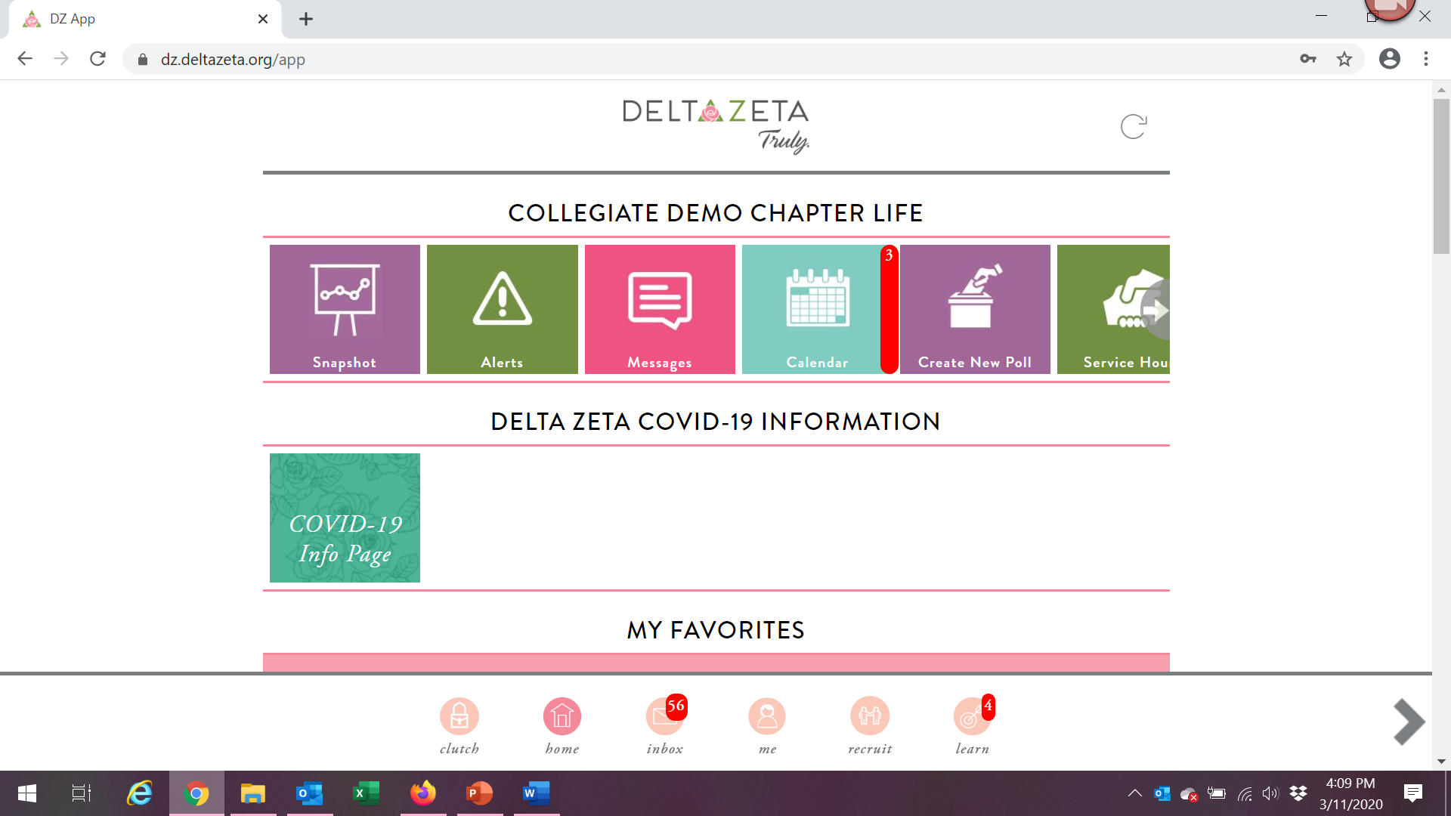
Step 2 – Conduct voting.
DZ Chapter Voting Tool – used for membership selection. Many members have used and downloaded the app in the past. Each member can vote only once on each “PNM” which is what we will call the topic to be voted on. Only active members can log in and vote. Only Chapter President and CCD can view results.
- Log in to https://chaptervoting.deltazeta.org/, and set up a new recruitment period like you would for recruitment under Add New Recruitment period.
- Add a new recruitment period with an end date in the future.
- Name the voting round what you are voting on, such as “Chapter Budget,” and save.
- Your first voting round is saved automatically.
- Go back to manage the recruitment period.
- Add one PNM name by clicking Actions – Add new PNM.
- First name and last name should be Chapter Budget and give it a PNM ID of 1.
- The voting round will appear for members on their voting tools.
- Use the radio buttons 1 for NO and 5 for YES for members to cast a vote. They can also make a comment. Make sure to click Publish to save votes
- Members can change their votes, but only one vote per member is saved.
- The Chapter President and CCD can view the votes on the manage side of the Chapter Voting tool and use the export PNM spreadsheet and export comments reports to view chapter member votes.
- Close the voting period manually using the Actions – Close recruitment round, or by waiting for the date of the recruitment period to pass.
